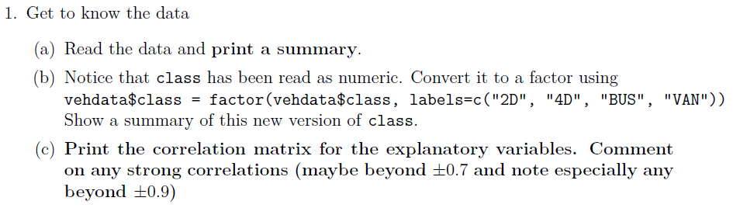

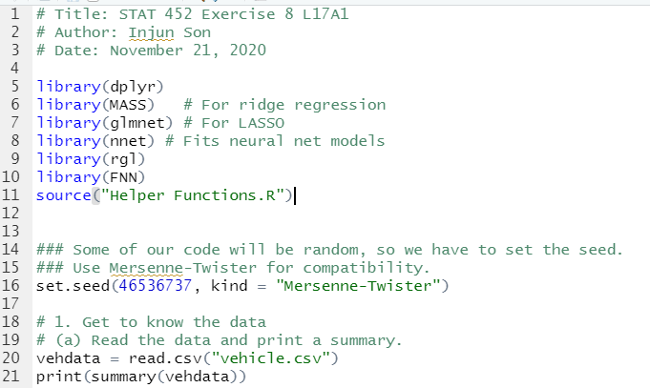

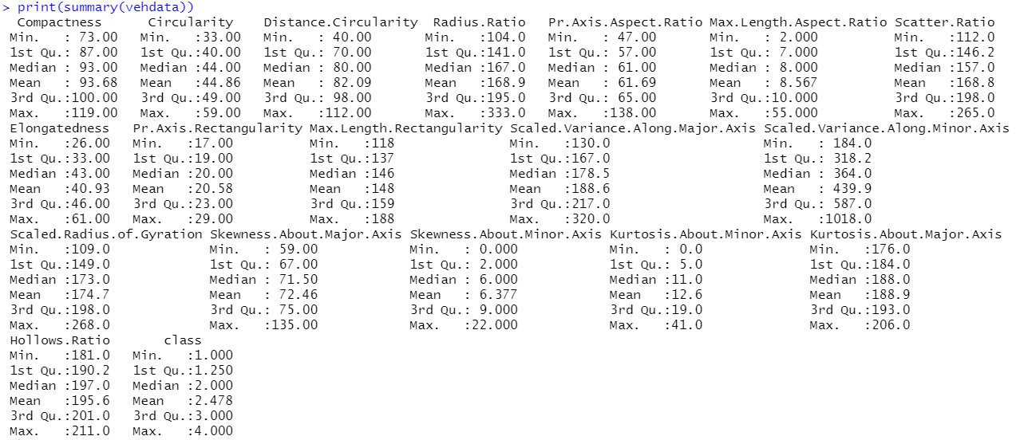

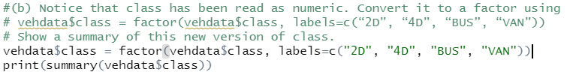

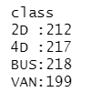

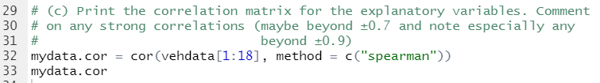

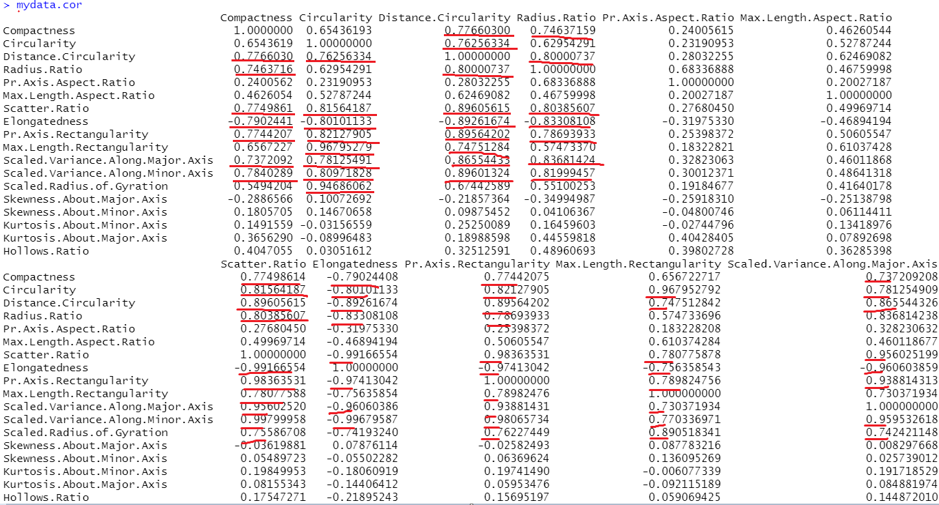

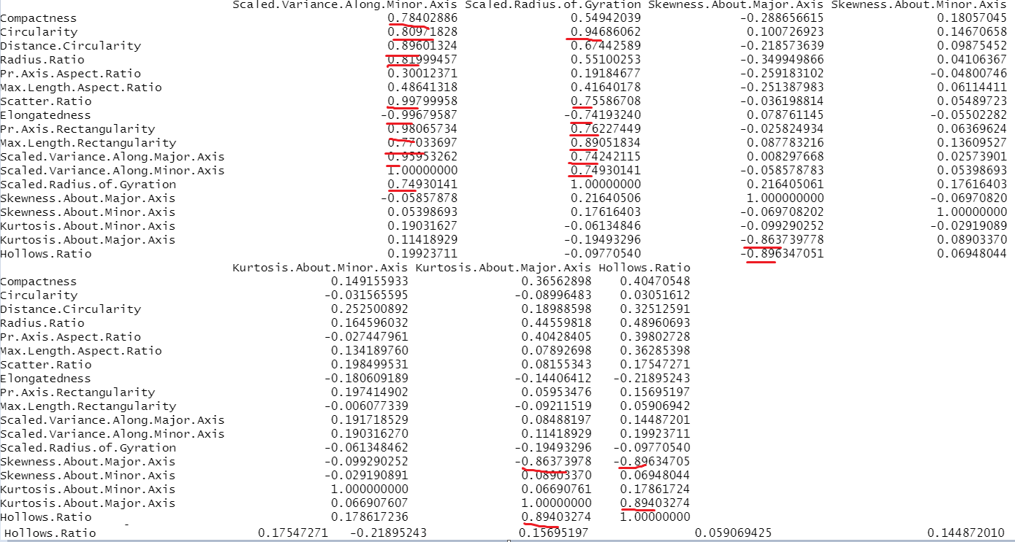

It looks like Compactness, Circularity, Distance.Circularity, Radius.Ratio, Scatter.Ratio, Pr.Axis.Rectangularity , Max.Length.Rectangularity, Scaled.Variance.Along.Minor.Axis have quite many correlation with other variables.